GOPINAľH N

zzzzz

**MSBI Kc:clopcí**

Phone: **+**91-7806851411 | E-mail: [gopinath.nagesh005@gmail.com](mailto:gopinath.nagesh005@gmail.com) |LinkedIn |Bangalore

# PROFESSIONAL SUMMARY:



* Experienced Developer with 6+ years of expertise in designing, developing, and optimizing cloud-based data pipelines using Snowflake and SSIS.
* Proficient in creating impactful data visualizations in Power BI and Excel, helping businesses make data-driven decisions. Adept at data migration, cloud architecture, and leveraging various BI tools to drive business growth.

# PROÏESSIONAL OVERVIEW:

### MSBI DEVELOPER

#### Six Sigma Soft Solutions Pvt Ltd, Chennai. Feb 2023 – Nov 2024

* As a MSBI Developer, I monitored scheduled jobs, supported migration activities to Snowflake, and created SQL server agent jobs with SSIS packages for daily ETL processes.
* I also implemented changes in production by creating change requests in Service Now.
* Designed and developed power bi dashboards to send the data to end users for data analytics, processed periodic data and published periodically for end users

### BI DEVELOPER

#### Astraes Engineering Pvt Ltd, Bengaluru. Dec 2020 – Aug 2022

* As BI Developer, I was responsible for loading and transforming data through various layers, maintaining SQL databases, and collaborating with cross-functional teams to deliver solutions.
* I optimized ETL processes using SSIS and developed SQL Server database solutions to meet reporting requirements and support critical business reports.

### PROJECT COORDINATOR/DATA ENGINEER

#### Astra Engineering Solutions, Bengaluru. Sep 2017 – Dec 2020

* As Project Coordinator, I analyzed systems and business requirements to create data transformations, developed Event Handlers, and utilized various data processing tools to enhance package functionality.

## TECHNICAL SKILL OVERVIEW:

* **Functional Knowledge:** Agile project management, Requirement Documentation, Writing user stories, Process improvement, Solution implementation, Data Analysis and visualization.
* **Domain Expertise:** Periodic Sales Management, Sales restatement, Sales reporting.
* **People Skills:** Excellent Communication skills, Problem-solving, Conflict resolution, Stakeholder management, Collaboration, Self- starter, highly adaptable, Prioritization.
* **Tools:** SQL (MS SQL), SSIS, ADF, AWS(S3), Snowflake, MS Office Suite (Excel, Teams, Word, PowerPoint), Power BI.
* **Remote Work:** Virtual collaboration via Microsoft Teams and zoom, Time Management, Document Management, Adaptability to time zones, Remote onboarding and training.

## EDUCAľION:

**B.E -** Mechanical Engineering

###### 7.96 CGPA

Anna University, Chennai.

# TECHNICAL SKILLS

##### Database Management and development

###### SQL

* Snowflake
* T-SQL

##### Data Integration

###### SSIS

* Azure Data Factory

##### Data Analysis and Reporting

* MS Power BI
* MS Excel

##### Data Warehousing and Cloud flatforms

###### AWS (S3)

* Snowflake

##### Automation & Scripting

* SQL Jobs
* SSIS Packages

## PROJECT EXPERIENCE

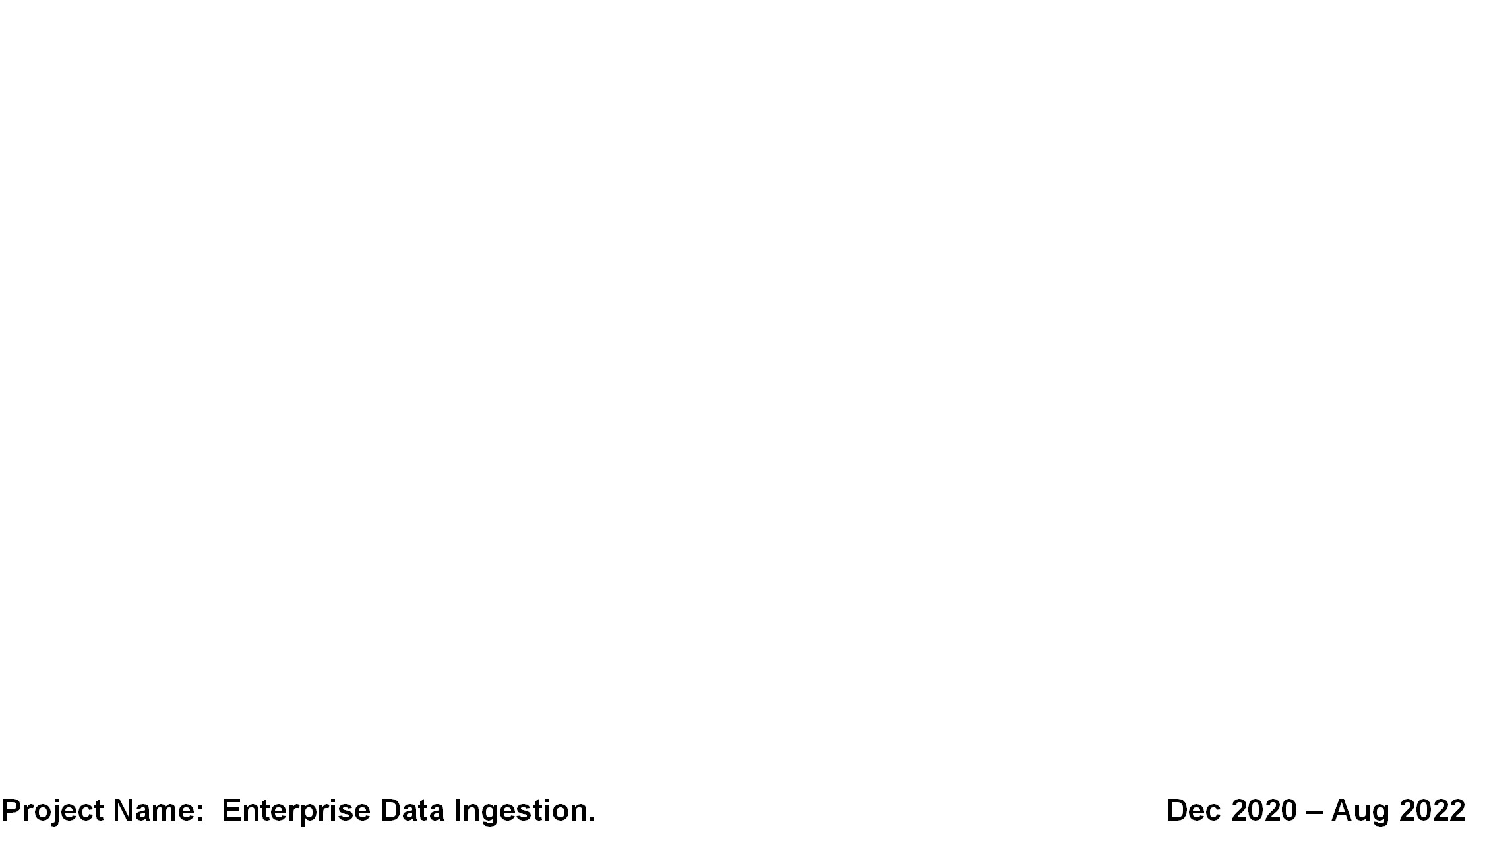

##### Project Name: Sainsbury’s. Feb 2023 – Nov 2024

* + Designing, developing, and implementing database structures and solutions for high-performance data processing and reporting.
  + Optimized **ETL workflows** by refining existing SSIS packages to ensure faster data processing, reducing job execution times by 40%.
  + Designed and developed **ETL pipelines** using **SSIS, T-SQL** and **Azure Data Factory (ADF)** to migrate and transform data between on-premises SQL Server and **Snowflake** and **AWS (S3)** environments.
  + Designing the structure of the **Data warehouse** to optimize storage and retrieval.
  + Optimized **Snowflake queries** and implemented **data models** that reduced data processing times by 30% while ensuring efficient use of cloud resources.
  + Streamlined ETL processes using **Snowflake and T-SQL,** improving data accuracy by 18%.
  + Perform database tuning to optimize the performance of queries, indexes, and system resources.
  + Monitor database system performance and create reports for operational monitoring and optimization.
  + Monitor the automated ETL pipeline in **Apache airflow** and **Dagster** for data processing.
  + Documenting technical function and technical design using **MIRO** and Familiarity with **ServiceNow** and Jira.
  + Document and standardize coding practices, procedures, and database workflows.
  + Collaborating with data architects and business stakeholders to translate requirements into technical solutions.

**Project Name: Enterprise Data Ingestion. Dec 2020 – Aug 2022**

* + Loading Common data to standard data through the various layers. Maintaining **SQL** Databases which contains all the configurations for the Transformations.
  + Maintaining SQL Databases which contains all the configurations for the Transformations. Building and optimizing complex **ETL** processes using **SSIS** to transform and load data from various sources.
  + Designing and developing SQL Server database solutions, including tables, stored procedures, and functions.
  + Managed data pipelines to handle batch processing and real-time data integration from various operational systems.
  + Provided ongoing support for SSIS package deployment and performance tuning, ensuring the system’s scalability and robustness.
  + Working with business stakeholders to understand reporting requirements and develop reports Build and maintain SQL procedures and ETL processes.
  + Develop, create store procedure, packages, functions, views for critical business reports.

##### Project Name: Business Process Management Sep 2017 – Dec 2020

* + Developing and managing dashboards using Excel, including pivot tables, HLOOKUP, VLOOKUP, and other advanced Excel functions.
  + Supporting the finance and sales teams with data analysis and reports. Handling data entry, data management, and data accuracy checks.
  + Generating periodic reports for management review. Collaborating with various departments to gather data and ensure the timely preparation of reports.

# DECLARATION

I, hereby declare that the above-mentioned details are true to the best of my knowledge.